**Project Design Phase-II**

**Data Flow Diagram & User Stories**

|  |  |
| --- | --- |
| Date | 23 May 2023 |
| Team ID | NM2023TMID11311 |
| Project Name | CovidVision: Advanced COVID-19 Detection from Lung X-rays with Machine Learning or Deep Learnings |

**Data Flow Diagrams:**

A Data Flow Diagram (DFD) is a traditional visual representation of the information flows within a system. A neat and clear DFD can depict the right amount of the system requirement graphically. It shows how data enters and leaves the system, what changes the information, and where data is stored.

**Example:** [**(Simplified)**](https://developer.ibm.com/patterns/visualize-unstructured-text/)

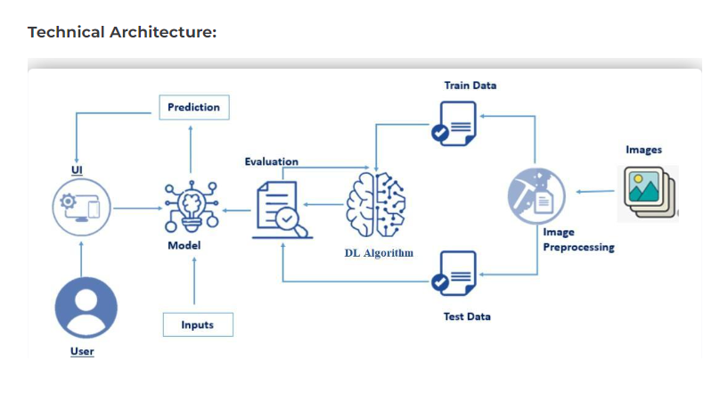

**User Stories**

| **User Type** | **Functional Requirement (Epic)** | **User Story Number** | **User Story / Task** | **Acceptance criteria** | **Priority** | **Team Member** |
| --- | --- | --- | --- | --- | --- | --- |
| Customer (use readings) | Readings | USN-1 | As a user, I can easily to know the status of covid lung detection easily | I can check my status | High | Thanga ganesh |
| Customer (application user) | login | USN-2 | As a user, I will surely conform the covid lung detection is present or not | I can check cancer is present or not | High | David |
| Customer (image user) | image | USN-3 | As a user, I can easily upload my image and the reading to find the level of covid lung detection | I can check while upload an image | Low | Asho xs blesslin |
| Customer (status user) | readings | USN-4 | As a user, it was easy and advanced process to check the status of covid lung detection | I can check the status | Medium | Rajesh |